


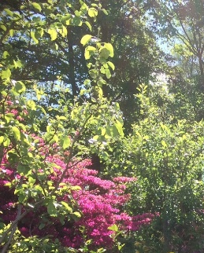



CAT CUMBRIA EVENT, 16th May, 2026
CAT CUMBRIA AIMS to increase access to CAT in the Lake District and be a support network for CAT therapists in remote and rural areas.
Date & Time: Saturday. May 16th, 10am – 4.30pm.
Venue: Hawkshead, near Ambleside. Overlooking fells and Esthwaite Water. 50 minutes from M6, junctions 36 or 40. Directions to be provided on booking.
Co-Ordinator: Barbara W. Williams, AFBPsS, CAT Psychotherapist & Supervisor
The day will give time for informal networking and exploring the outside world.
Workshop : Emotional Release
Facilitator: Barbara Williams
In the past decade or so, many new therapists have emphasised the importance of working with bodily sensations to deal with threat, abandonment and past trauma. These include IFS, AEDP, Memory Consolidation, Deep Brain Re-Orienting and techniques based on Polyvagal Theory. Evidence from neurological studies form the background to these approaches.
In the 70’s, I attended workshops with John Heron, Human Potential Research Project at Surry University. He introduced us to a range of “cathartic techniques” aimed to release distress held in the body. At this in-person experiential workshop, I ‘d like to share some of these methods with you, as I think they fulfil similar functions to those described in the above approaches, and are easily incorporated into CAT’s middle phase.
Barbara is an ACAT accredited psychotherapist and supervisor. After working in the NHS for 40 years or so, she has retired from her consultant post to Cumbria where she has a small independent practice. In 2016, she founded CAT CUMBRIA which provides discussion forums reflective spaces to support CAT therapists in their work.

Cost: voluntary contributions will be appreciated on the day to cover the cost of refreshments which will be provided. Ma
Transport: please let me know if you can offer or would like to request a lift, e.g. from Liverpool, Newcastle, Lancaster, Oxenholme Lake District, or Grange-Over-Sands.
To Book, or for further information email: barbara.williams.1@outlook.com with your dietary requirements. Places are limited and on a first- come- first- served basis.


