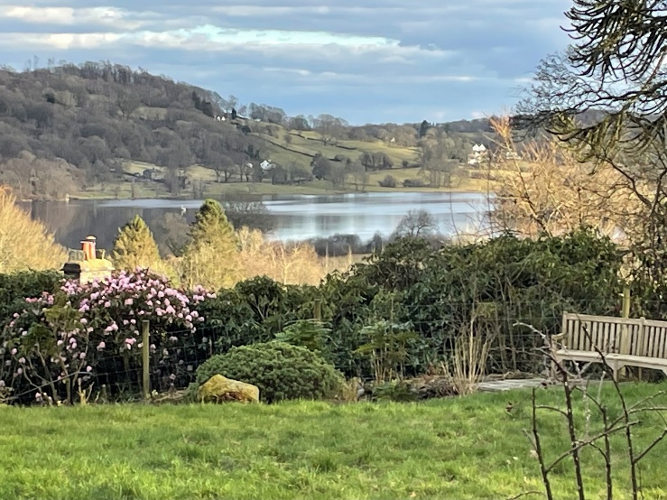
CAT CUMBRIA
Does the CAT model need developing/changing?
Annie Nehmad
Saturday 11 October 2025, 10.00 - 4.30

CAT CUMBRIA aims to increase access to CAT in the Lake District and be a support network for CAT therapists in remote and rural areas. It also offers an opportunity for “townies” to experience the restorative feel of the Lake District.
Venue: Hawkshead, near Ambleside. Overlooking the Fells and Esthwaite Water. 50 minutes from M6, junctions 36 or 40. Directions to be provided on booking.
Co-Ordinator: Barbara W. Williams, AFBPsS, CAT Psychotherapist & Supervisor
About the Workshop
CAT practice has always been open to incorporating techniques or skills from other models. However, the CAT model itself has not changed. Its theories of personality development, psychopathology and mechanisms of change have remained unaltered since the introduction of Vygotskian and Bakhtinian ideas some thirty years ago. Meanwhile, there have been important developments:
- Neuroscientific discoveries, and Polyvagal Theory
- New therapies (eg EMDR, AEDP, IFS)
- A new understanding of the importance of the body as the location of trauma. Therapies which work through the body, including Peter Levine’s Somatic Experiencing and Pat Ogden’s Sensorimotor Psychotherapy, were developed in the 1960’s and 1970’s but have recently gained a wider recognition among therapists.
This workshop considers some of these developments, and whether the CAT model, which remains “disembodied”, may need to change.
Annie Nehmad is a founder member of ACAT. She is also a Solution Focused Therapist and has partially trained in EMDR and AEDP
Cost: voluntary contributions on the day will be appreciated to cover presenter expenses and refreshments which will be provided. Estimated cost depending on the number of participants will be £50.
To Book, for further information, or to let us know your dietary requirements, please email: barbara.williams.1@outlook.com. Places are limited and on a first-come first-served basis.
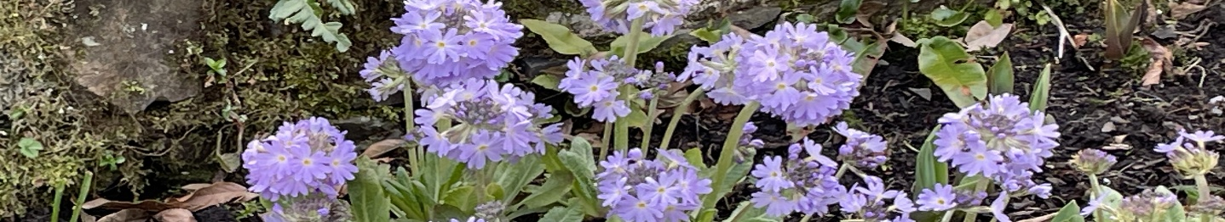
Transport: please let me know if you can offer or would like a lift, e.g. from Liverpool, Newcastle, or a train station

